How to Adjust Agent Metric Collection Rates

While monitoring your Citrix Virtual Apps and Desktops or VMware Horizon environment(s), Goliath collects many metrics. Depending on your environments density/configuration, this can be an intensive process and we have seen some customer environments that are not able to handle the load. The collection process can be modified improve agent performance/load on the affected machines.

Refer to the steps below for instructions on adjusting the collection. Please note, the below steps are only applicable for Goliath Agents running v11.8.0 and newer.

Adjusting Agent Metric Collection

1. RDP to the Goliath Server
2. Open Windows File Explorer and Navigate to the **Bin** folder within the Goliath Server install directory.
   1. The default location is either **C:\Program Files (x86)\MonitorIT\Bin** or C**:\Program Files\MonitorIT\Bin** depending on your Goliath version
3. Sort the folder by File Name in ascending order, at the top you will see a file named **AgentCollectionRates.txt** double click to open the file.  
   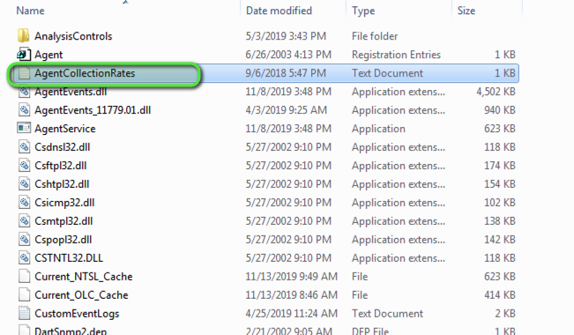
4. Once the file is opened, you will see a list of the metric collection items and their corresponding rates, defined in seconds.
   1. 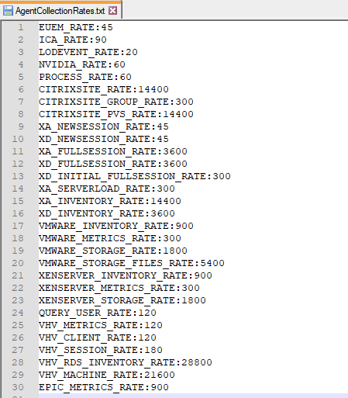
5. Update the applicable rate(s). Once ready, save and close the file.
   1. See the below sections for [Metric Collection Rates Overview](https://support.goliathtechnologies.com/hc/en-us/articles/360060239533-How-to-Adjust-Agent-Metric-Collection-Rates#h_01G6N9K0X33Q0EZTDBMGX98PJ7) and [Collection Recommendations](https://support.goliathtechnologies.com/hc/en-us/articles/360060239533-How-to-Adjust-Agent-Metric-Collection-Rates#h_01G6N9KCA9E40Z07ZR77EEF3D6) for additional details on the metrics and potential rate changes.
   2. To disable a metric from being collected, enter a rate of **2147483647**
6. The updated collection rate(s) will now be applied the Goliath Agents within 60 seconds.

Metric Collection Rates Overview

Please reference the below a table which describes the each metric collection items.

|  |  |
| --- | --- |
| **Collection** | **Description** |
| EUEM_RATE | Citrix End User Experience Metrics (ICA RTT, Network Latency, Logon Duration Brokering stages) |
| ICA_RATE | Citrix ICA Latency, Connection Speed and ICA Channel |
| LODEVENT_RATE | Citrix Logon Duration |
| NVIDIA_RATE | NVIDIA vGPU metrics |
| PROCESS_RATE | Windows Process Metrics displayed within a Citrix/Horizon session |
| CITRIXSITE_RATE | Citrix Topology View |
| CITRIXSITE_GROUP_RATE | Citrix Topology View |
| CITRIXSITE_PVS_RATE | Citrix Topology View |
| XA_NEWSESSION_RATE | Citrix Virtual Apps -  New Sessions |
| XD_NEWSESSION_RATE | Citrix Virtual Desktops - New Sessions |
| XA_FULLSESSION_RATE | Citrix Virtual Apps - Full Sessions |
| XD_FULLSESSION_RATE | Citrix Virtual Desktops - Full Sessions |
| XD_INITIAL_FULLSESSION_RATE |  |
| XA_SERVERLOAD_RATE | Citrix Virtual Apps -  Server Load |
| XA_INVENTORY_RATE | Citrix Virtual Apps -  Inventory Collection |
| XD_INVENTORY_RATE | Citrix Virtual Desktop -  Inventory Collection |
| VMWARE_INVENTORY_RATE | VMware vCenter - Inventory Collection |
| VMWARE_METRICS_RATE | VMware vCenter - Metric Collection |
| VMWARE_STORAGE_RATE | VMware vCenter - Storage Collection |
| VMWARE_STORAGE_FILES_RATE | VMware vCenter - Storage Collection |
| XENSERVER_INVENTORY_RATE | XenServer - Inventory Collection |
| XENSERVER_METRICS_RATE | XenServer - Metric Collection |
| XENSERVER_STORAGE_RATE | XenServer - Storage Collection |
| QUERY_USER_RATE |  |
| VHV_METRICS_RATE | Vmware Horizon - Metric Collection |
| VHV_CLIENT_RATE | Vmware Horizon Monitoring |
| VHV_SESSION_RATE | Vmware Horizon - Session Collection |
| VHV_RDS_INVENTORY_RATE | Vmware Horizon - RDSH Inventory Collection |
| VHV_MACHINE_RATE | Vmware Horizon - Desktop Inventory Collection |
| EPIC_METRICS_RATE | Epic System Pulse - Metric Collection |

Collection Recommendations

If you are looking to dial back the collection rates, please find a list of recommended conservative and aggressive values.

|  |  |  |  |
| --- | --- | --- | --- |
| **Agent Collection Rate** | **Default Value** | **Conservative Value** | **Aggressive Value** |
| EUEM_RATE | 45 | 67.5 | 90 |
| ICA_RATE | 90 | 135 | 180 |
| LODEVENT_RATE | 20 | 30 | 40 |
| NVIDIA_RATE | 60 | 90 | 120 |
| PROCESS_RATE | 300 | 450 | 600 |
| CITRIXSITE_RATE | 14400 | 21600 | 28800 |
| CITRIXSITE_GROUP_RATE | 300 | 450 | 600 |
| CITRIXSITE_PVS_RATE | 14400 | 21600 | 28800 |
| XA_NEWSESSION_RATE | 45 | 67.5 | 90 |
| XD_NEWSESSION_RATE | 45 | 67.5 | 90 |
| XA_FULLSESSION_RATE | 3600 | 5400 | 7200 |
| XD_FULLSESSION_RATE | 1800 | 2700 | 3600 |
| XD_INITIAL_FULLSESSION_RATE | 300 | 450 | 600 |
| XA_SERVERLOAD_RATE | 300 | 450 | 600 |
| XA_INVENTORY_RATE | 14400 | 21600 | 28800 |
| XD_INVENTORY_RATE | 3600 | 5400 | 7200 |
| VMWARE_INVENTORY_RATE | 900 | 1350 | 1800 |
| VMWARE_METRICS_RATE | 300 | 450 | 600 |
| VMWARE_STORAGE_RATE | 1800 | 2700 | 3600 |
| VMWARE_STORAGE_FILES_RATE | 5400 | 8100 | 10800 |
| XENSERVER_INVENTORY_RATE | 900 | 1350 | 1800 |
| XENSERVER_METRICS_RATE | 300 | 450 | 600 |
| XENSERVER_STORAGE_RATE | 1800 | 2700 | 3600 |
| QUERY_USER_RATE | 300 | 450 | 600 |
| VHV_METRICS_RATE | 120 | 180 | 240 |
| VHV_CLIENT_RATE | 120 | 180 | 240 |
| VHV_SESSION_RATE | 120 | 180 | 240 |
| VHV_RDS_INVENTORY_RATE | 28800 | 43200 | 57600 |
| VHV_MACHINE_RATE | 21600 | 32400 | 43200 |
| EPIC_METRICS_RATE | 900 | 1350 | 1800 |